Fort Loramie Local Schools – How To Create Account
Parent Login web address: https://loramie.esvportal.com/
OneView is a secure platform, designed to be a one-stop location for parents to connect with the school,
update their information, fill out school forms, and access any other resources such as ProgressBook.
STEP ONE: CREATE A PARENT ACCOUNT
Parent(s) will create ONE ACCOUNT for all of their students. That account will stay with the parent(s) during
their time that their students are enrolled in Fort Loramie Local Schools. In addition, when younger siblings reach
enrollment age, the parent(s) can begin the student enrollment process electronically.
All parents and guardians will need to create an account to fill out their forms.
From the OneView login screen click the
“Create A New Account” button. This will take
you to the page where you can create your
parent account.
Create your account by providing your:
•
•
•
•
•
•
Name
Email Address
Account Login ID – this is created by you and not supplied by the district
Password
Forgot Password Question/Answer, and a
Pin Code (The PIN code is used for verification and can be any 4 or 5 digit number).
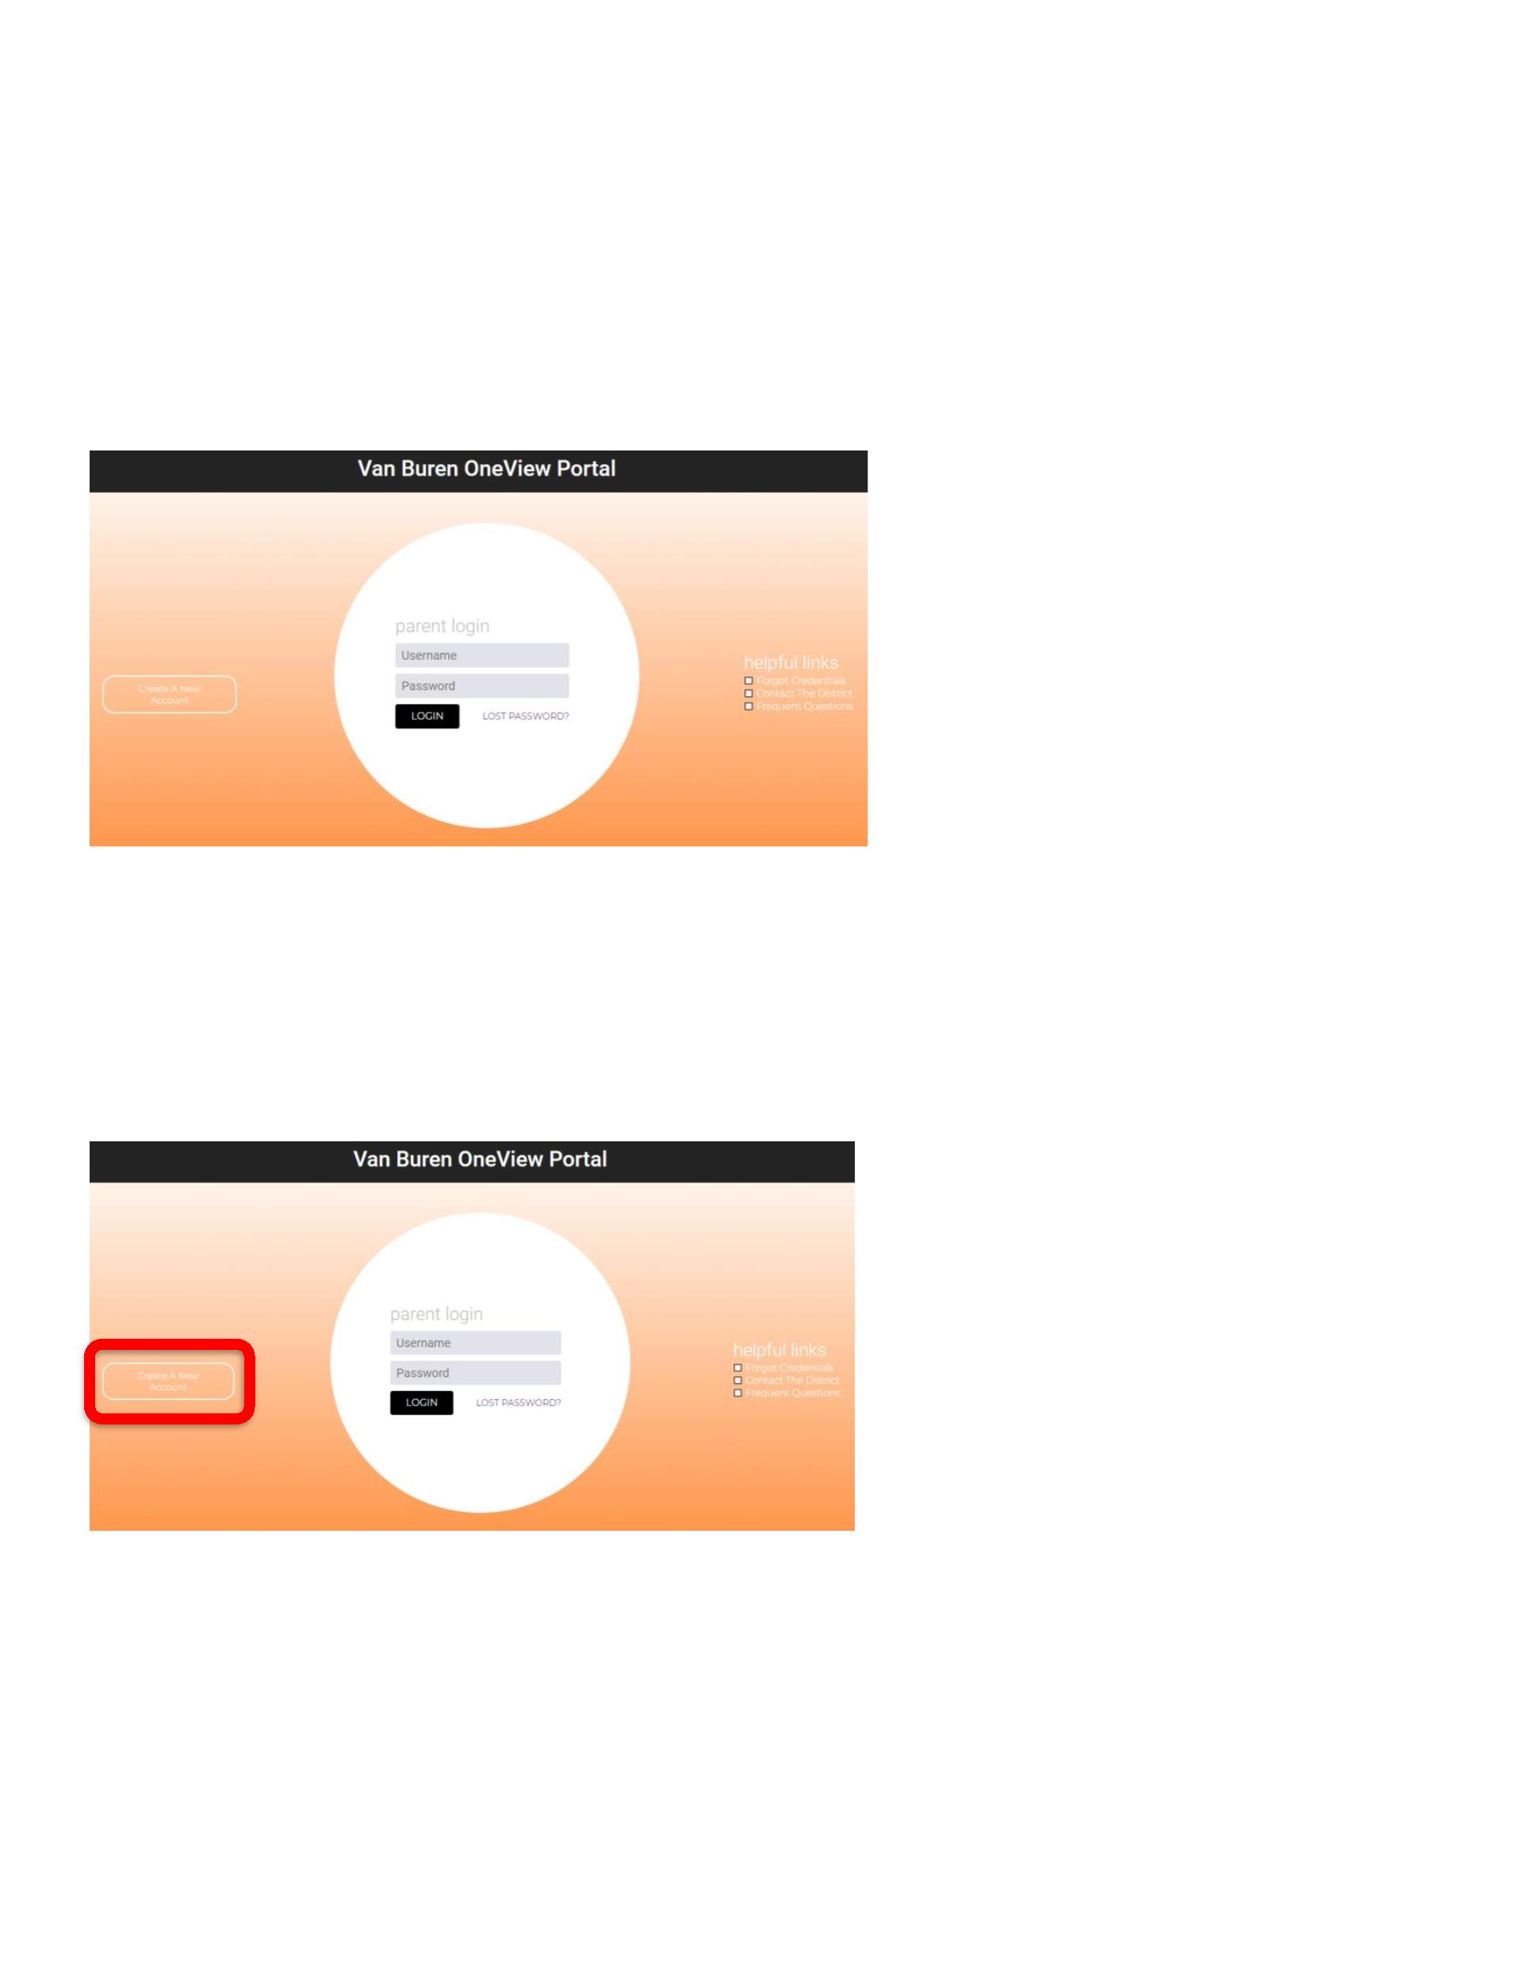
- From the district website, you may click on the link OneView Portal. You will then be taken to the OneView Parent Login page.
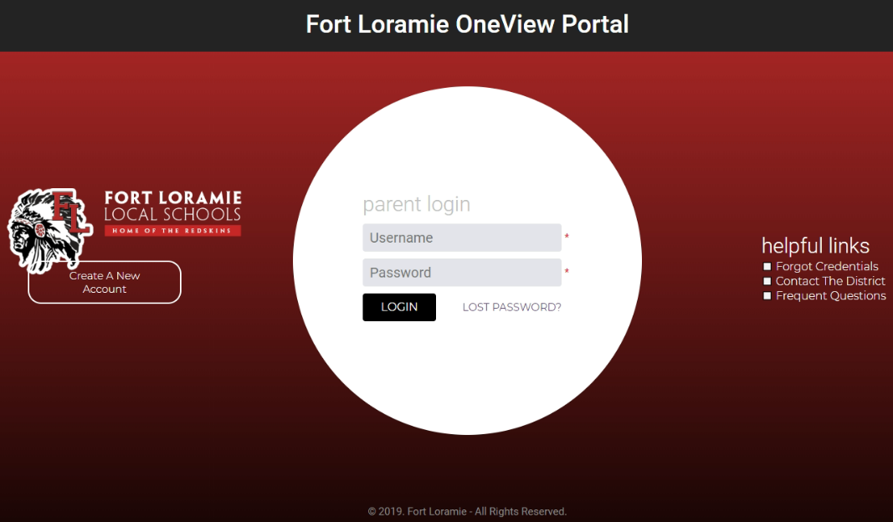
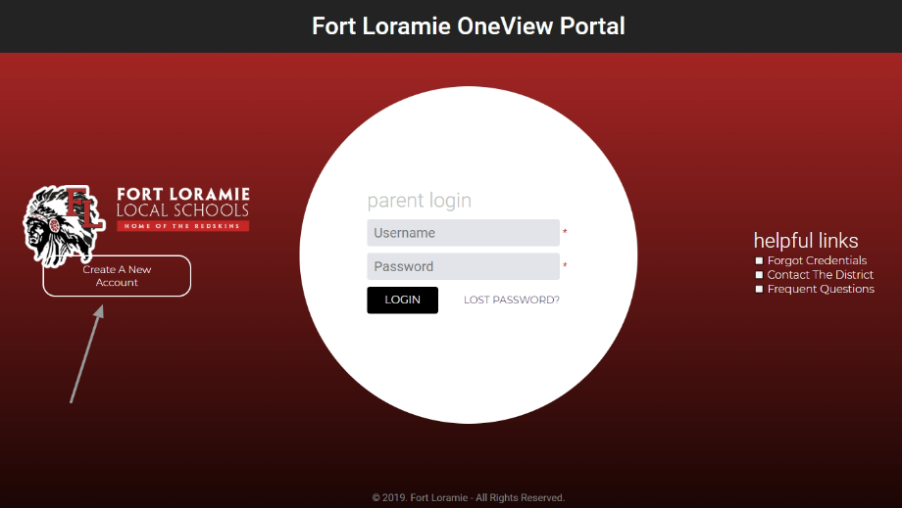

Create your own parent username.
IMPORTANT – select forgot password question
IMPORTANT - Create a 4 digit pin number
Click Register & Begin
Then click “Register & Begin” to get started. A confirmation email will be sent to the parent once they
create their account.
STEP TWO: ATTACH STUDENTS.
If your student(s) are not attached to your account, (not visible in the right hand margin of the screen) you must
attach (or link) your student(s) to the parent account.
This can be accomplished two different ways:
Option #1 (preferred option):
Use the invitation code that was emailed to you.
Option #2:
Parents may attach their students by providing the following details:
•
•
•
•
Student’s last name
Grade level
Date of birth
Student ID number (can be found on ProgressBook or by contacting the building secretary:
shelley.middendorf@loramie.k12.oh.us or jody.ruhenkamp@loramie.k12.oh.us )
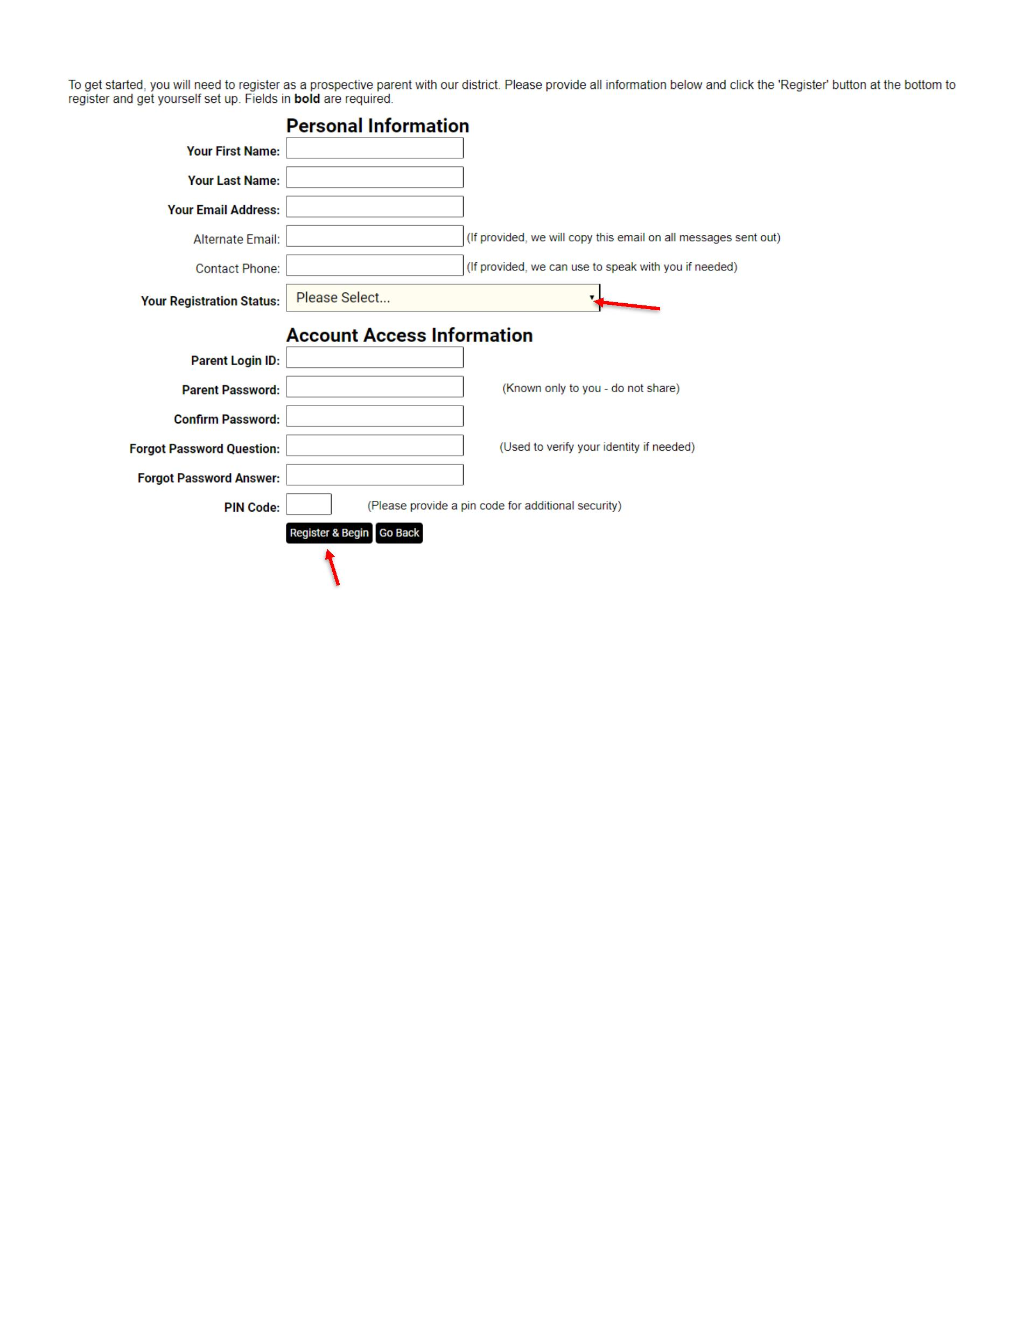

STEP THREE: VIEW THE DASHBOARD AND NAVIGATE BETWEEN STUDENTS
Once a parent attaches their students, they can click on the “Enrolled Student Dashboard” to view their
student’s information.
•
•
Parents can navigate between individual students by using the drop-down box highlighted on the right.
On the dashboard page, parents can access ProgressBook, view the district calendar, access
PayForIt.net, and manage their school forms submissions.
Pull down menu if
you have more
than one student
registered
Parents can manage their students by clicking “Manage My Students” and can manage their own account
information by clicking “Update My Account.”
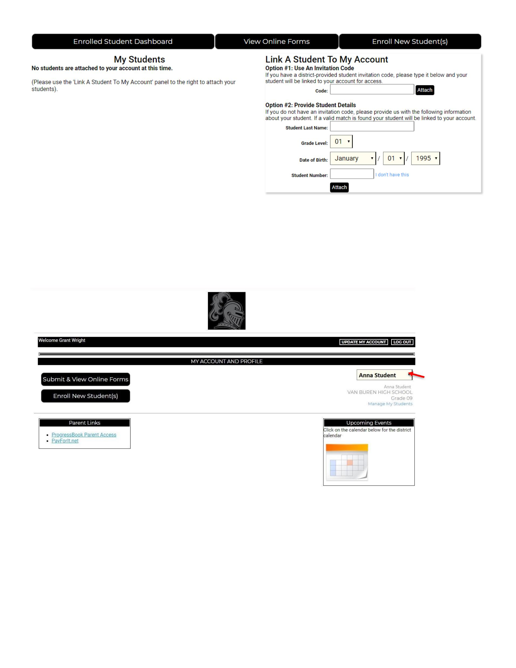
The “Enroll New Student(s)” button will take a parent to the beginning of the new student enrollment process.
Do not click Enroll New Student(s) if your student(s) are already enrolled and are attending Fort Loramie Local Schools.
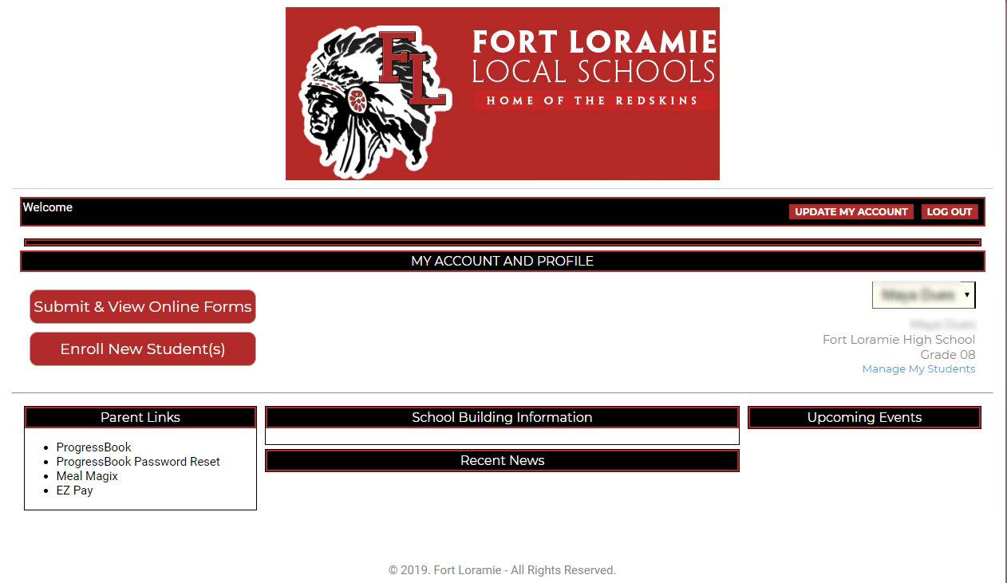
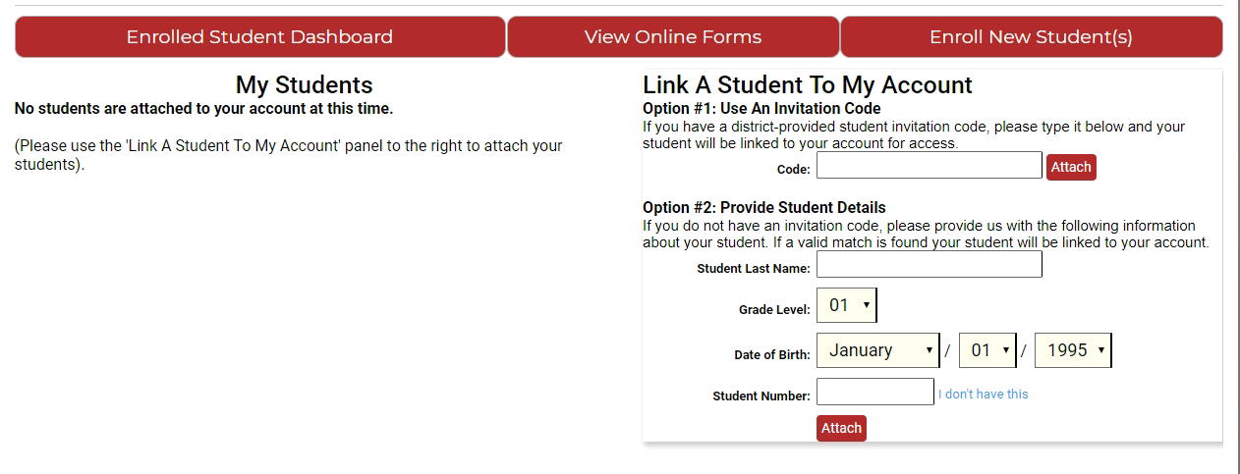

STEP FOUR: FILLING OUT AND SUMBITTING ONLINE FORMS
By clicking “Submit & View Online Forms,” parents can view and fill out their back to school forms. Once filled
out and submitted, a parent can access their forms to make any necessary changes (such as address
changes) at any time during the school year.
Forms to be completed:
•
•
•
Emergency Medical Form
Athletics Form
Medication Forms (If applicable, these will need to be printed, completed, and submitted to the school
office)

If you have any questions about the Athletics Form, please contact Mitch Westerheide at mitch.westherheide@loramie.k12.oh.us or call the office at 937-295-3342.
Please click on the links provided to each document. Fill out all the information required and when done, be sure to click on SAVE & SUBMIT. You will then be notified if your document has been approved. (Once your EMA form has been approved, you may then complete your Athletics Form).
